Modal Testing Excitation Consideration

Overview
Sentek Dynamics’ MS Series Modal Shakers are proven solutions for Experimental Modal Analysis. The MS Series are designed for laboratory experiments, modal studies and structural analysis and are available in different force rate. They cover a wide range of modal analysis applications. No matter the device under test is a PCB card, automotive component, power machinery, passenger car, airplane, or space craft, one of the MS series modal shaker can be acquired to carry out the test.
There are a few modal testing methods considering different type of excitation used. Commonly known, they are Hammer Impact and Modal Shaker. The Operational Modal Analysis which take use of the Ambient Excitation is not discussed here.
Hammer impact testing uses an Impact Hammer to excite the structure under test. The impulse force applied to the structure is categorized into the broadband range excitation, due to fact it contains the energy up to certain frequency range. The hammer impact test is quick to set up and to carry put, thus is widely used. Also, it has its limitations, and some concerns need to be considered.
Modal shaker testing takes use of the modal shaker to excite the structure under test. There is a list of waveform types can be selected to excite the structure under test. It is more often used for complex or large scale structural testing. Compared to the hammer impact test, it is more repeatable. On the other hand, Modal shaker testing requires more hardware, i.e., modal shaker(s), stinger, more input and output channels from the dynamic signal analyzer. The test setup would require experienced user.
Ambient excitation uses natural excitation of structure, will results in the response only measurement data. This can be used for testing on bridges, buildings, etc., in the civil engineering field. It does not require any boundary condition setup, and no excitation equipment is needed. Due to the lack of knowledge of excitation, unscaled modal data will be resulted. The analysis will require special processing.

Hammer Impact Testing
When using impact hammer to run the modal testing, there are two ways to perform the measurement. One is roving hammer, with a fixed response measurement point, and the excitation point is roving over the measurement DOFs on the structure under test. The FRF signals between the fixed response measurement DOF and excitation DOFs are acquired. And this results in one row of FRF signals.
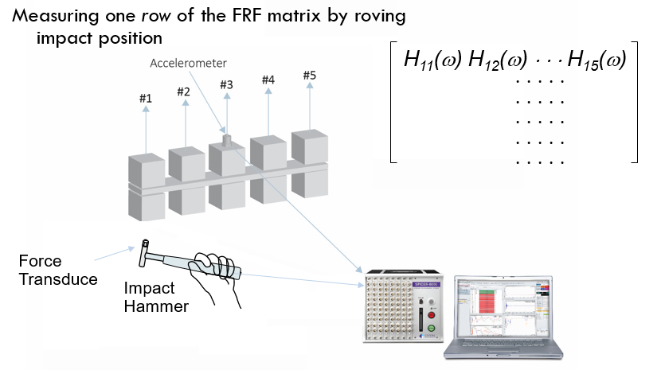
Roving hammer test
Equivalently, roving response method can be used. The responses can be measured at several DOFs, while the excitation is fixed at one DOF on the structure under test. With this arrangement, a column of FRF signals will be acquired. With possible multiple responses measured at the same time, more FRF signals can be measured at the same time. This will speed up the testing process. But this will result in the so-called mass loading issue, due to the moving the response accelerometers are moving from one batch of measurement point and direction to the next. To handle this issue, either dummy blocks can be applied to all DOFs are not under measurement; or ultimately take use enough accelerometers to measure all DOFs in one shot.
The structure under test varies from case to case. And this would require different size of hammers. The vendors of testing equipment typically supply the mini hammer for the PCB board testing, to the large sledge hammer for huge rotor testing from power plant.
The Hammer tip or its material plays a big role considering the upper frequency the test will need. The software tip hammer will result in relatively lower level impact with wider width of time. From the frequency domain, the auto power spectrum of the impact pulse will decay sooner than that from the harder hammer tip on. The following graph illustrates this in time domain and frequency domain. The rule is to pick the hammer tip material that its auto spectrum decays less than 6 dB to the upper frequency of the setup.
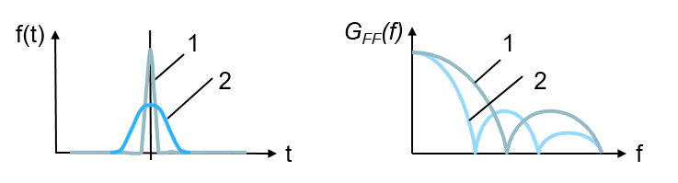
Soft (2) vs hard (1) tip of the hammer
To alleviate the leakage, Force/Exponential window shown as following can be applied.
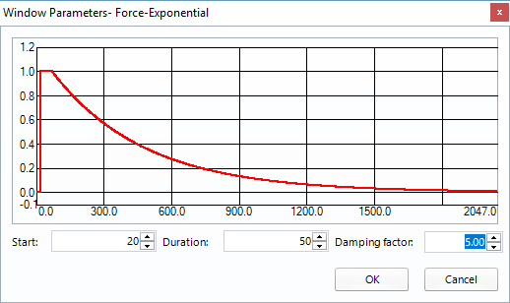
Force/Exponential window with setup parameters
With the application of this window, the response channel data can be decaying to zero as shown in following graphs.
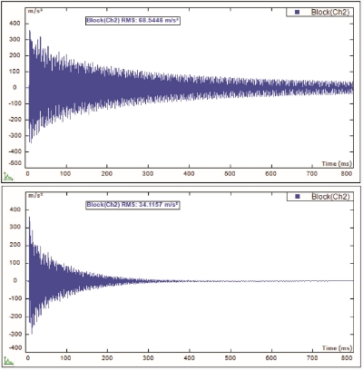
Response signal after Force/Exponential window
Though the Force/Exponential window helps to deal with the leakage issue, but it introduces extra damping to the result. Technically, the extra damping introduced can be extracted after the modal results are identified. If it is possible, increase the block size first to allow more measurement time so that the responses from the structure under test can decay to close to zero level. If this is the case, then no Force/Exponential window will be applied.
Double hit is a very common phenomenon during hammer impact testing. It tends to happen more easily when the hammer is hitting at the edge of the structure. When it happens, the spectrum of the excitation will be distorted and thus causes the measured FRF signal distorted too. When this happens, the current set of data will be discarded. Many modal software is implemented with the double hit detection and auto reject feature. With it is turned on, the data can be rejected automatically when double hit is detected.
Driving point defines the measurement for which its response DOF is the same as the excitation DOF. It can be used to help select the fixed driving point DOF for roving response hammer test, or the fixed response point DOF for roving excitation hammer test. The process is to select several DOFs on the mesh of the structure under test. Then the test to measure FRF will be performed. By checking these FRF signals from the Driving point selection process, the driving point from which the FRF illustrate most of the resonance peaks, and the valley exists between any two of resonances can be chosen as the driving point. This is done with the hammer impact test, but the result can be applied for the modal shake test too. The selected DOF can be applied for the modal shaker test to attached the driving stinger from the modal shaker.

Modal Shaker Testing
With Modal Shaker Excitation testing the structure is excited at one fixed DOF, and Responses are measured at number of DOFs. FRF signals between response DOFs and excitation DOF are computed. With single input (excitation) multiple output (response), one column of FRF signals are measured. When the input channel count of the Dynamic Signal Analyzer is not high enough to cover all the measurement DOFs in one shot, the measurement sensors can be roved and the measurement can be repeated to finish all the required response DOFs.
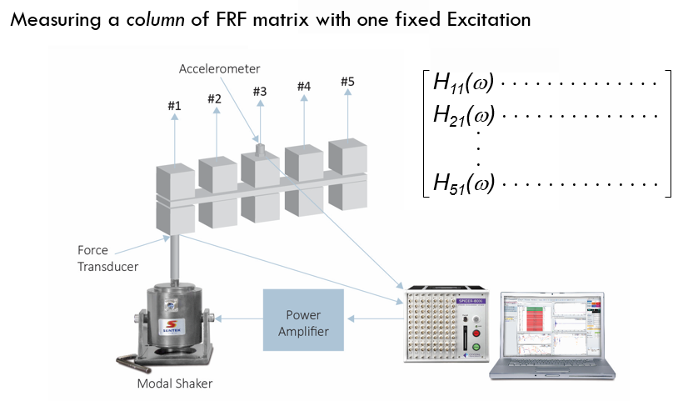

To drive the modal shaker, an output channel from the Dynamic Signal Analyzer will be used to drive the amplifier of the modal shaker. There are many waveform types are available to drive the structure under test. Commonly, the Pure Random (Gaussian Random, or White Noise) can be the choice to drive the structure under test. Due to the nature of leakage, window, i.e., Hann window needs to be applied with this type of excitation waveform.
Another commonly used excitation waveform for Modal Shake testing is the Burst Random. The signal type is still random nature, but it will output the random with user defined percentage, and then keeps no drive sending out. This way, the structural response will decay within the zero-output duration of each block of data. In case the response does not decay enough, the percent of the burst random can be tuned to increase the zero-output period. With this achieved, there will be no leakage and thus no windowing would be required. And this is the main reason for the choice of Burst Random type of excitation.
Periodic Random and Pseudo Random are another category of random waveforms. The Pseudo Random is defined as an ergodic, stationary random signal consisting of energy content only at integer multiples of the FFT frequency lines (Δf). The linear spectrum of this signal is shaped to have a constant amplitude, but with random phase. The following figure illustrates this constant amplitude characteristics of the pseudo random signal.
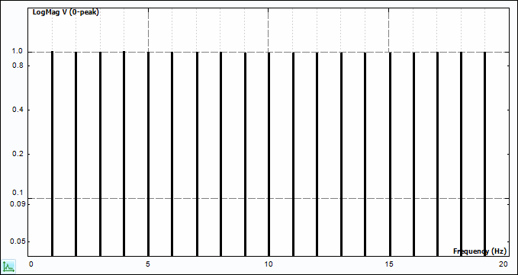
Pseudo Random Signal Spectrum
When sufficient delay time is allowed in the measurement procedure, any transient response to the initiation of the signal will decay, and the resultant input and output blocks are periodic with respect to the sampled period (block size).
The Periodic Random signal is also an ergodic, stationary random signal consisting only of integer multiples of the FFT frequency increment. The frequency spectrum of this signal has random amplitude and random phase distribution. Following figure shows the spectrum characteristics.
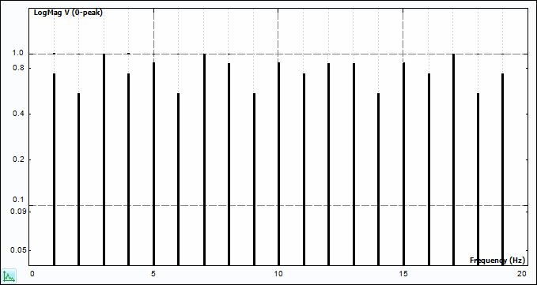
Periodic Random Signal Spectrum
For each spectral average, input signal is generated with random amplitude and random phase. The system is excited with this input multiple blocks, until the transient response to the change in excitation signal decays. The input and response histories should then be periodic with respect the block-size and are saved as one spectra average in the total process. With each new average, a new block of signal, random with respect to previous input signals, is generated so that the resulting measurement will be completely randomized.
Also available as excitation waveforms are the sine type, i.e., Chirp, Burst Chirp.
Sometimes multiple excitation testing may be required, and this is referred as Multiple Input Multiple Output (MIMO) testing. It is more often used for large and supple structures’ modal testing. With use of multiple modal shakers, the excitation energy will be sufficiently distributed to excite the global modes of the structure under test. Simply increasing the driving force with single shaker arrangement, will overstress the driving point, and caused nonlinearity behavior of the structure.
Besides, for structures that have repeated modes, or highly coupled modes, MIMO modal testing will result in multiple columns of FRF. With this information, the repeated modes or highly coupled modes can be identified, using the corresponding FRF matrix. It needs to point out that the parameter identification method to handle the poly-reference FRF matrix will be the poly-reference type too. With identified mode participation factor, the repeated or highly coupled modes can be isolated.

